# Clonar Repo

# Instalar Dependencias

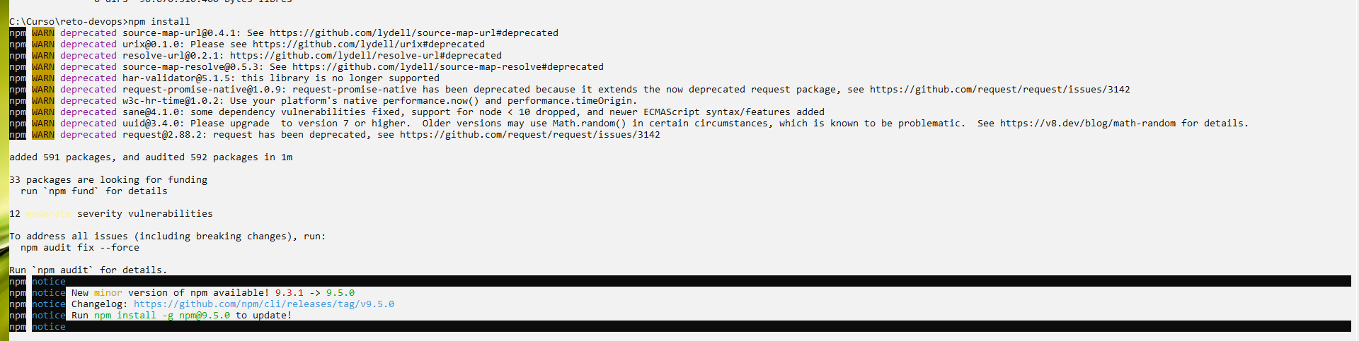

# Ejecutar Test

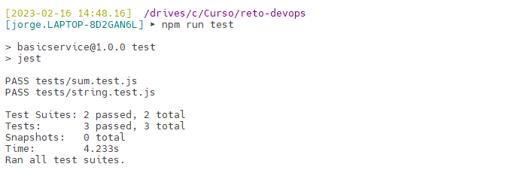

# Ejecutar la app

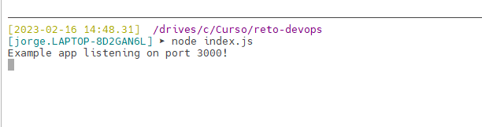

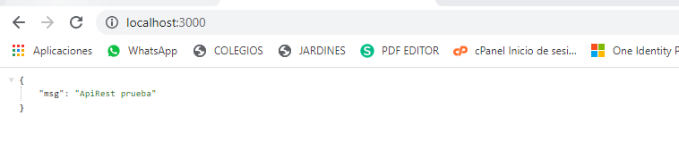

# Reto 1. Dockerize la aplicación.

### Dockerfile

FROM node:16

# Create app directory

WORKDIR /usr/src/app

# Install app dependencies

# A wildcard is used to ensure both package.json AND package-lock.json are copied

# where available (npm@5+)

COPY package*.json ./

RUN npm install

# If you are building your code for production

# RUN npm ci --only=production

# Bundle app source

COPY . .

EXPOSE 3000

CMD [ "node", "index.js" ]

### Construimos la imagen

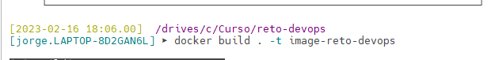

### Imagen lista



# Reto 2. Docker Compose.

### Docker-Compose

version: '3.1'

services:

service-reto-devops:

container_name: container-reto-devops

image: image-reto-devops

restart: always

ports:

- 3000:3000

### Ejecutamos el docker-compose

### 